**PHYS 121 Labs**

# Fluid Viscosity

**Warm-up questions:**

• What is the difference between moving through air (something you do daily) and moving through water (which you may not have tried)?

• How do movements in water compare to movements in honey?

**Goals of this lab**

1. To learn how to use instruments and tools for measurement.
2. To measure fluid viscosities using (i) falling ball, (ii) capillary.

## Introduction and background

Viscosity is a measure of a fluid’s resistance to flow. It describes how internal friction within the fluid resists motion when layers of the fluid move relative to one another. For example, honey has a much higher viscosity than water, which means it flows more slowly under the same conditions. In physical terms, viscosity arises from intermolecular forces and momentum transfer between adjacent layers of the fluid. It plays a central role in characterizing whether a fluid behaves more like a "thick" or "thin" substance during motion.

Viscosity plays a critical role in the analysis and design of systems involving fluid motion. It determines the rate of energy dissipation in viscous flows, influences boundary layer formation, and governs flow regimes characterized by the Reynolds number. In practical terms, viscosity affects fluid transport in pipelines, lubrication in mechanical systems, and thermal regulation via convective heat transfer. Accurate characterization of viscosity is also essential in biomedical, aerospace, and microfluidic applications, where precise control of flow behavior is required for optimal performance and efficiency.

here are two main types of viscosity: dynamic (or absolute) and kinematic. The former one is usually referred to viscosity. This property may be thought of as fluid friction. The adjacent layers of fluid move with different velocities. In a steady laminar flow where velocity $υ_{x}$ in *x* direction, the shear stress $τ_{x, z}$ is given by

|  |  |  |
| --- | --- | --- |
|  | $$τ_{x, z}=η\frac{dυ_{x}}{dz}$$ | (1) |

where $η$ is viscosity, $z$ is a spatial coordinate normal to the area where shear stress acts, and $\frac{dυ_{x}}{dz}$ is velocity gradient or shear rate. The unit for (dynamic) viscosity is Pa·s where

1 Pa·s = 1 N·s/m2 = 1 kg·m-1 ·s-1

When the shear stress is linearly proportional to velocity gradient, the viscosity is constant for a given temperature or pressure. A fluid that behaves in this way is called Newtonian fluid. All gases and most simple liquids such as water and castor oil are Newtonian.

Kinematic viscosity $ν$ is the measure of the fluid’s inherent resistance to the flow. It is given by

|  |  |  |
| --- | --- | --- |
|  | $$ν=\frac{η}{ρ}$$ | (2) |

where $ρ$ is fluid mass density and the unit of kinematic viscosity is m2/s or mm2/s.

A number of techniques are used to measure the viscosity of fluids. These are typically based on one of three phenomena: (i) an object moving through a fluid, (ii) fluid flowing through a resistive component, and (iii) a moving surface in contact with a fluid. These phenomena utilize three major viscometers in the industry, i.e., falling-ball, capillary, and rotational viscometers. In this lab we will use the first two techniques to measure fluid viscosities. The third one is optional.

**Experiment 1. Viscosity measurement using a falling ball viscometer**

#### Theory

With this type of viscometer, a small steel ball is dropped into the castor oil being measured. The dimensions of the ball are already known (measured by the micrometer), so viscosity is determined by timing how long it takes to fall through the castor oil via gravity/buoyant force/viscous drag.

One model that could be used to compute the viscous drag force is based on Stokes’ Law (for laminar flow). When a ball falls through the fluid (i.e., castor oil) it will experience a viscous drag force*.* According to Stokes’ Law, the viscous drag force *f* is given by

|  |  |  |
| --- | --- | --- |
|  | $$f=3πηυd$$ | (3) |

where $η$ is the viscosity of the castor oil, $υ$ is thevelocity of the ball, and $d$ is the diameter of the ball.

Another model (for turbulent flow) is

|  |  |  |
| --- | --- | --- |
|  | $$f=\frac{1}{2}​C_{D}​ρAv^{2}$$ | (4) |

where 𝐶𝐷 is the drag coefficient (depends on shape and flow conditions, indirectly related to viscosity), 𝜌 is the fluid density, 𝐴 is the cross-sectional area of the object, and 𝑣 is the relative velocity.

*Which model should you use here?*

As a ball is dropped from rest into the castor oil, there are three forces acting on it during its fall in the oil, including the weight of the ball *mg*, buoyant force *Fb* and viscous drag force *f* (*draw a free-body diagram*). Initially when the ball is dropped into the oil, it accelerates as a result of the gravitational field during a transient period (between the liquid surface and N1 in Figure 1a) until it reaches a terminal velocity $υ$ which becomes constant. This is the steady-state regime of the fall of the ball (between N1and N2 in Figure 1a, *how to verify this?*). It occurs when the viscous drag force and the buoyant force exactly balance the weight of the ball.

|  |  |  |
| --- | --- | --- |
|  | $$mg= F_{b}+f$$ | (5) |

This buoyant force experienced by the ball can be described as:

|  |  |  |
| --- | --- | --- |
|  | $$F_{b}=ρg\frac{4}{3}π{(d/2)}^{3}$$ | (6) |

where $ρ$ is the density of the castor oil.

The weight of the steel ball can be described as:

|  |  |  |
| --- | --- | --- |
|  | $$mg=ρ_{0}g\frac{4}{3}π{(d/2)}^{3}$$ | (7) |

where $ρ_{0}$ is the density of the steel ball.

Combining Equations (3), (6) and (7) as per Equation 5 yields the balance of the forces acting on the ball when it is falling at terminal velocity.

|  |  |  |
| --- | --- | --- |
|  | $$\frac{1}{6}ρ_{0}gπd^{3}=\frac{1}{6}ρgπd^{3}+3πηυd$$ | (8) |

By rearranging Equation (8), we are able to determine the viscosity *η* of the castor oil

|  |  |  |
| --- | --- | --- |
|  | $$η=\frac{(ρ_{0}-ρ)gd^{2}}{18υ}$$ | (9) |

**Experiment set-up and procedure**

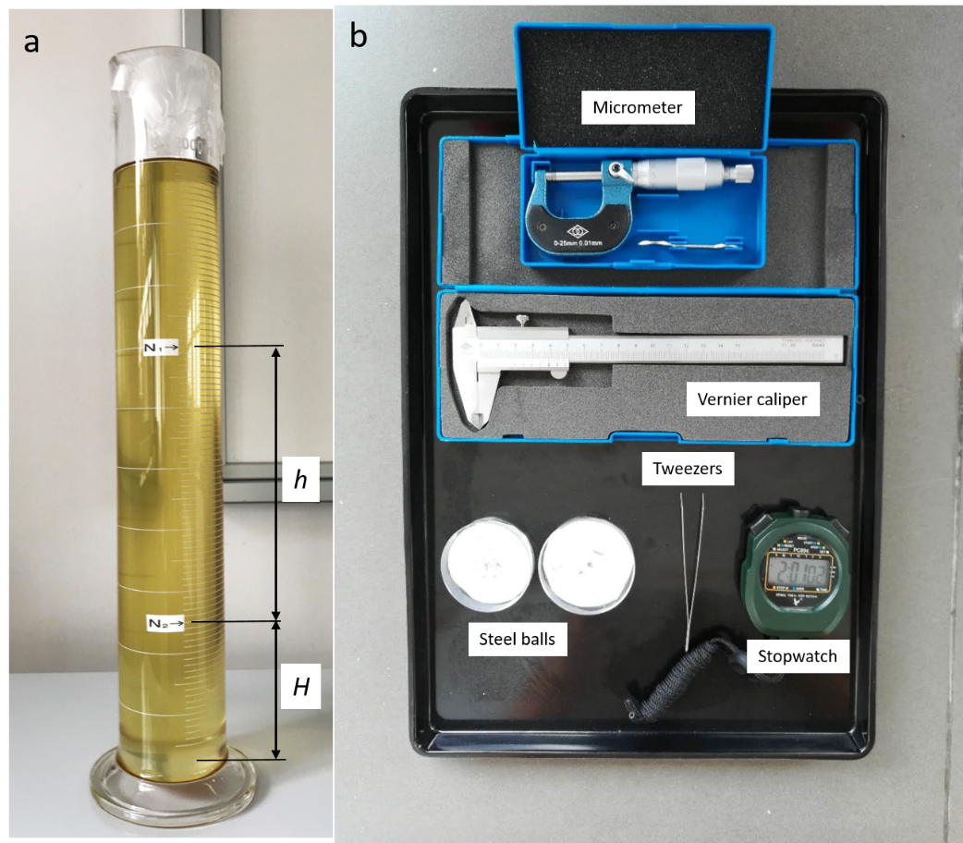

**Figure 1** Experiment set-up of the falling ball method

Perform the experiment according to the following steps and record all the data as required in your **LAB NOTEBOOK**.

1. Take note of the room temperature $T$ ( ͦC) in order to determine the density of the castor oil $ρ$.
2. Measure the inner diameter *D0* of the glass cylinder using a **VERNIER CALIPER**.
3. At your lab station you will find two sizes of steel balls (0.9 and 1.2 mm, by design). One group member will need to choose a 0.9 mm steel ball and the other will need to choose a 1.2 mm ball to perform the experiment.

Take a steel ball with tweezers and measure the diameter $d$ of the ball using a **MICROMETER** (read the manual in the manual folder). Repeat this measurement **6-8 times** by measuring the steel ball in different angles. Draw a table similar to Table 1. in your lab notebook and fill out the table with your data.

1. Record the travel time $t$ of the ball over the measured distance *h*. Repeat this measurement with 6 steel balls of the same size. Fill out Table 2.

**NOTE**: To do this, DROP the ball into the castor oil from the CENTER above the liquid surface, and use the stopwatch to record the time for the ball to fall from N1 to N2. Check the instructions for stopwatch in the manual folder.

1. **After lab** you will need to analyze the measurement error (Table 3) based on the data you collected in Table 1. You need to determine the velocity $υ$ of the ball, viscosity $η$ of castor oil, and fill out Table 2. Transfer your final data to the template and complete the data analysis and answer the questions there.

**Data analysis and questions**

You should keep all raw data including units in your lab notebook. Below shows examples of how you should record your data in your lab notebook. The raw data that **YOU** (not your partner) have collected and data analysis **MUST** be all included in the lab report. The questions are optional part to be included in the report.

1. Room temperature: $T$ = ______ ± 0.2 ͦC.

After lab, you will need to determine the density of the castor oil (kg/m3) using the empirical formula

|  |  |  |
| --- | --- | --- |
|  | $$ρ (T)=974-0.614·T$$ | (10) |

1. Graduated cylinder: *D0* = ______ ± 0.02 mm ( = 0.02 mm), $h$ = 200.3 ± 1.0 mm ( $U_{h}$ = 1.0 mm)
2. Density of the ball: *ρ*0= (7.80 ± 0.05) × 103 kg/m3 ( = 0.05 × 103 kg/m3)

**Table 1.** Diameter of the steel ball

|  |  |
| --- | --- |
| Measurement # | $d$ (mm)  0.9 mm 1.2 mm |
| *d*0 (zero error) |  |
| *d*1 |  |
| *d*2 |  |
| *…..* |  |
| *d*n (n > 5) |  |

1. **Table 2.** Travel time and velocity of the ball and the viscosity of castor oil

|  |  |  |  |
| --- | --- | --- | --- |
| $t$ (s)  0.9 mm 1.2 mm | $\overline{t}$ (s) | $υ$ (m/s)  ($υ=h/t$) | $η$ (Pa·s)  (Equation 8) |
|  |  |  |  |
|  |
|  |

1. **Table 3.** Error analysis for DIRECT measurements (after lab)

|  |  |
| --- | --- |
| $$d^{'}=\overline{d}-d_{0}$$ |  |
| Standard deviation/Bessel’s Correction $$s=\sqrt{\frac{1}{n-1}\sum_{i=1}^{n}{{\left(d_{i}-\overline{d}\right)}^{2}}}$$ |  |
| Standard uncertainty $$U_{d}=\sqrt{\frac{S^{2}}{n}}$$ |  |

$d$ = $d^{'}±U_{d}=______±________mm$.

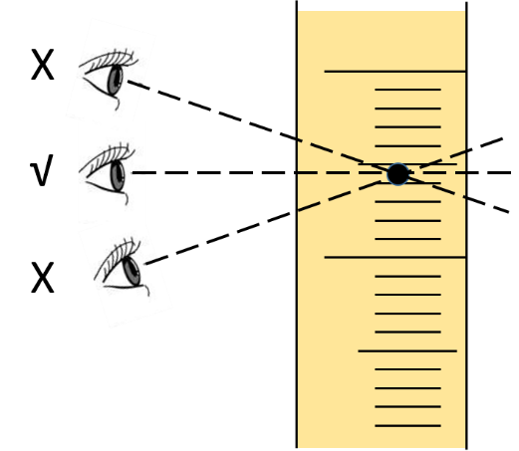

**Figure 2** Parallax error

***Questions:***

1. *How do you know if the steel ball reaches the terminal velocity when it reaches to N1? Try to estimate when the ball reaches a constant velocity.*
2. *How to reduce parallax error when the steel ball is dropping through N1 and N2?*

***Parallax error*** *is the error/displacement caused in the apparent position of the object due to the viewing angle that is other than the angle that is perpendicular to the object’s movement (Figure 2).*

1. *What are the factors that cause errors during the measurement? Which do you think is the primary one? How to improve the experiment?*
2. *Does the position where you drop the steel ball affect the measurement?*
3. *What happens if the graduated cylinder is tilted?*
4. *What happens if the diameter of the steel ball d is three times larger?*

Error analysis for INDIRECT measurements

*In many real-life situations, we have the following problem: we want to know the value of some characteristic $y$ that is difficult to measure directly (e.g., distance to a distant quasar, efficiency of an engine, etc.). To estimate $y$, we must know the relationship between $y$ and some directly measurable physical quantities $x_{1}$, …, $x_{n}$. From this relationship, we extract an algorithm $f$ that allows us, given $x_{i}$, to compute $y$ using $y=f(x_{1}, …,x_{n} )$. So, we measure $x_{i}$ ( $i$ = 1,2…n), apply an algorithm $f$ to the measurement results ${\tilde{x}}_{i}$, and get the desired estimate $\tilde{y}=f({\tilde{x}}_{1}, …, {\tilde{x}}_{n} )$. This procedure is called an indirect measurement of $y$.*

*The error $∆y= \tilde{y}- y$ can be expressed as*

|  |  |  |
| --- | --- | --- |
|  | $$dy=\sum{\frac{∂f(x_{i})}{∂x_{i}}dx_{i}}$$ | *(11)* |

*The uncertainty $U_{y}$ can be expressed using the approximate formula*

|  |  |  |
| --- | --- | --- |
|  | $$U_{y}=\sum{\frac{∂f(x_{i})}{∂x_{i}}U_{X_{i}}}$$ | *(12)* |

To determine the uncertainty of the viscosity of castor oil $U_{η}$, the combination of Equation 9 and $υ=h/t$ yields

|  |  |  |
| --- | --- | --- |
|  | $$η=\frac{(ρ_{0}-ρ)gd^{2}}{18h/t}$$ | (13) |

An easy way to compute $U_{η}$ is take the natural logarithm of both sides of Equation (13) and we obtain

|  |  |  |
| --- | --- | --- |
|  | $$lnη=ln\left(ρ_{0}-ρ\right)+lng+2lnd-ln18-lnh+lnt$$ | (14) |

We take differential and obtain

|  |  |  |
| --- | --- | --- |
|  | $$\frac{∂η}{η}=\frac{∂\left(ρ_{0}-ρ\right)}{ρ_{0}-ρ}+\frac{2∂d}{d}-\frac{∂h}{h}+\frac{∂t}{t}$$ | (15) |

Hence, the uncertainty of viscosity of castor oil is expressed using the following approximate formula

|  |  |  |
| --- | --- | --- |
|  | $$U_{η}≅η\sqrt{{\left(\frac{{\sqrt{2}U}_{ρ}}{ρ_{0}-ρ}\right)}^{2}+{\left(\frac{2U_{d}}{d}\right)}^{2}+{\left(\frac{U_{h}}{h}\right)}^{2}+{\left(\frac{U_{t}}{t}\right)}^{2}}$$ | (16) |

Note: $\sqrt{2}$ comes from the uncertainty measurements of both $ρ_{0}$ and $ρ$.

Using Equations 13 and 16, you will need to determine $η'= η± U_{η}=$____±_____ with units.

**Note:** You shall keep TWO digits after the decimal point for the values of $η'$, $η$ and $U_{η}$.

### Experiment 2. Viscosity measurement using a capillary viscometer

#### Theory

Widely used for measuring the viscosity of Newtonian fluids, including dilute solutions and suspensions, the glass capillary viscometer is the simplest and least expensive viscometrical system available commercially. Typically, in this technique, the viscosity is determined by measuring the time required for a given fluid volume to flow through a defined length $l$ of glass capillary due to the hydrostatic pressure of the fluid column itself. This method is based on Poiseuille’s law or Hagen-Poiseuille’s law, which is given by

|  |  |  |
| --- | --- | --- |
|  | $$Q=\frac{V}{t}= \frac{{πr}^{4}δP}{8ηl}$$ | (17) |

where $Q$ is the flow rate, $V$ is the fluid volume, t is the flow time between marks M1 and M2 (Figure 3), $η$ is the fluid viscosity, $δP$ is the pressure difference between the two ends of the capillary, and $r$ is the radius of the capillary.

Taken together, $δP=ρgh$ and Equation (17), kinematic viscosity $ν$ is derived by

|  |  |  |
| --- | --- | --- |
|  | $$ν=\frac{η}{ρ}= \frac{{πr}^{4}gh}{8lV}t$$ | (18) |

where $ρ$ is the fluid density. In practice, it is hard to obtain precise values for $δP$, $l$ and $r$. Therefore, a standard liquid is used for **COMPARISON** purposes. The flow time $t_{s}$ required for a standard fluid of known kinematic viscosity and volume $V$ to flow through a capillary between two marked lines is measured, followed by measuring the flow time $t$ required for a test fluid of **SAME** volume $V$ to flow through the **SAME** capillary. We obtain

|  |  |  |
| --- | --- | --- |
|  | $$\frac{ν}{ν_{s}}= \frac{t}{t_{s}}$$ | (19) |

Therefore, the kinematic viscosity of the test fluid is given by

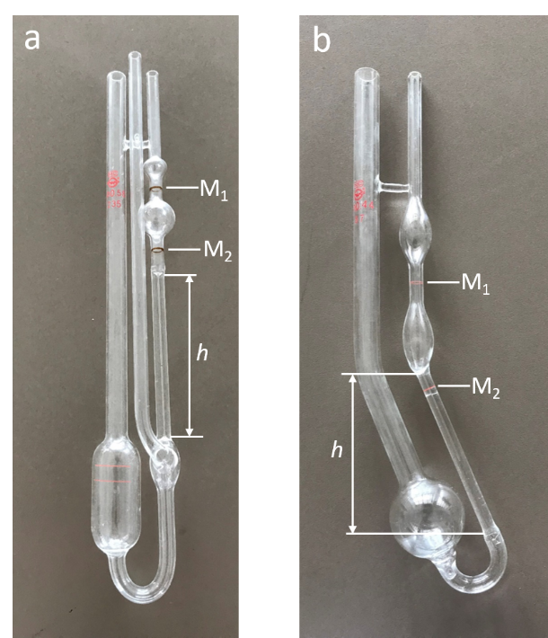

**Figure 3** Photos showing (a) Ubbelohde viscometer and (b) Cannon-Fenske viscometer

|  |  |  |
| --- | --- | --- |
|  | $$ν= \frac{ν_{s}}{t_{s}}t= \frac{η_{s}}{ρ_{s}t_{s}}t$$ | (20) |

**Experiment set-up and procedure**

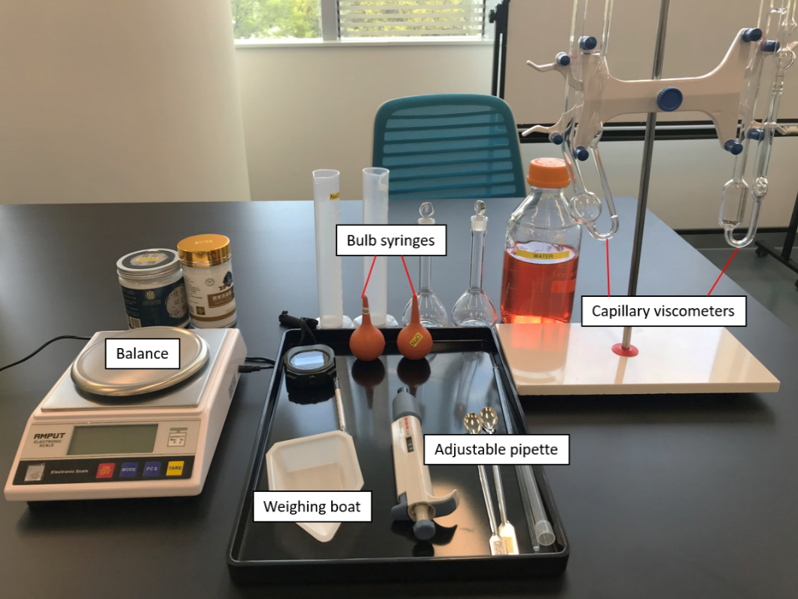In this experiment, two types of capillary viscometers are used, including Ubbelohde and Cannon-Fenske viscometers (Figure 3). You will measure the viscosity of 20% w/v (mass/volume) sugar or 10% w/v salt solution with a capillary viscometer.

**Figure 4** Experiment set-up of capillary viscometer method

1. Take a note of the room temperature $T$ ( ͦC) before the measurement for later use in finding the tabulated values of water density from the table in Appendix A.
2. Prepare 20% w/v sugar or 10% w/v salt solution by following steps a - d
3. Add water up to about 70 mL to a glass beaker.
4. Weigh out 20.00 ± 0.20 g sugar or 10.00 ± 0.20 g salt. Add sugar/salt to water gradually while stirring the solution with a glass stirrer.

**NOTE: DO NOT ADD THE POWDERED SUGAR BEFORE THE WATER OR YOU WILL MAKE ROCK CANDY! (*Why?*)**

1. Once fully dissolved, transfer the solution to a volumetric flask and carefully bring the solution to the final volume (100 mL) using water.
2. Transfer the fully dissolved solution to a graduated cylinder of 100 mL to determine its density using a Baumé scale.
3. The **DENSITY** of the prepared solution can be measured in degrees Baumé (Bé) using a Baumé scale (read the instruction in the manual folder). The specific gravity (*s.g*.) of the solution can be calculated using

|  |  |  |
| --- | --- | --- |
|  | $$s.g. = \frac{144.3}{144.3-degrees Baumé }$$ | (21) |

Specific gravity measures the density of a liquid $ρ$ in relation to water $ρ_{s}$, which is given by

|  |  |  |
| --- | --- | --- |
|  | $$s.g. = \frac{ρ}{ρ_{s}}$$ | (22) |

The density of prepared solution $ρ$ can be determined using Equation 22.

1. Choose an Ubbelohde or Cannon-Fenske viscometer to measure the viscosity of water as a standard fluid. Record the flow time $t_{s}$ required for water of certain volume to go through the capillary between two marked lines (repeat this for at least 5 more times). Read the instruction for viscometer in the manual folder. Within a temperature range of 0 – 40 ͦC, the viscosity of water (Pa·s) can be derived using the empirical formula

|  |  |  |
| --- | --- | --- |
|  | $$η_{s}(T)= 4.040625 × {10}^{-5}e^{\frac{418.6322}{T+110.4}}$$ | (23) |

The calculated value should have three digits after the decimal point.

**Note:** Add 13 mL [*why this value?*] of liquid to Ubbelohde viscometer or 8 mL of liquid to Cannon-Fenske viscometer for your measurement.

1. Remove the water from the viscometer.
2. Record the flow time *t* required for the test solution of the **SAME** volume to go through the **SAME** capillary. [repeat the measurement for 5 more times?]
3. When you finish the experiment, remove the test solution from the capillary and wash the viscometer with water for at least three times.
4. After lab calculate the viscosity of the test solution, fill out Table 4 and include this table in your report.

**Data analysis and questions:**

You should keep all raw data including units in your lab notebook. Below shows examples of how you should record your data in your lab notebook.

Choose **ONE** viscometer and **ONE** solution to perform the experiment.

**Table 4.** Viscosity measurement using capillary viscometer

|  |  |  |  |
| --- | --- | --- | --- |
|  | | Ubbelohde viscometer  Cannon-Fenske viscometer | Note |
| *T* ( ͦC) | |  | To measure |
| Water | (kg/m3) |  | Appendix A (after lab) |
| $η_{s}$ (Pa·s) |  | Equation 23 (after lab) |
| (m2/s) |  | Equation 2 (after lab) |
| $t_{s}$ (s) |  | To measure (6 times) |
| Salt  (10% w/v)  Sugar  (20% w/v) | Bé ( ͦBé) |  | To measure |
| (kg/m3) |  | Equations 21 & 22(after lab) |
| *t* (s) |  | To measure (6 times) |
| (m2/s) |  | Equation 19 or 20 (after lab) |
| $η$ (Pa·s) |  | Equation 2 (after lab) |

***Questions:***

1. *What happens if*
2. *the viscometer is tilted;*
3. *the volume of test fluid is different from that of standard fluid;*
4. *the temperature changes.*
5. *What are the other factors that influence the accuracy of the measurement?*
6. *Try to estimate $U_{η}$ of your test solution using Equations 14 – 16 (in the ‘Guideline about error analysis’ document.).*

**Appendix A**

1990 International Temperature Scale (ITS-90) Density of Water (kg/m3)

|  |  |  |  |  |  |  |  |  |  |  |
| --- | --- | --- | --- | --- | --- | --- | --- | --- | --- | --- |
| *t*(℃) | 0.0 | 0.1 | 0.2 | 0.3 | 0.4 | 0.5 | 0.6 | 0.7 | 0.8 | 0.9 |
| 10 | 999.699 | 999.691 | 999.682 | 999.672 | 999.663 | 999.654 | 999.644 | 999.634 | 999.625 | 999.615 |
| 11 | 999.605 | 999.595 | 999.584 | 999.574 | 999.563 | 999.553 | 999.542 | 999.531 | 999.520 | 999.508 |
| 12 | 999.497 | 999.486 | 999.474 | 999.462 | 999.450 | 999.439 | 999.426 | 999.414 | 999.402 | 999.389 |
| 13 | 999.377 | 999.384 | 999.351 | 999.338 | 999.325 | 999.312 | 999.299 | 999.285 | 999.271 | 999.258 |
| 14 | 999.244 | 999.230 | 999.216 | 999.202 | 999.187 | 999.173 | 999.158 | 999.144 | 999.129 | 999.114 |
| 15 | 999.099 | 999.084 | 999.069 | 999.053 | 999.038 | 999.022 | 999.006 | 998.991 | 998.975 | 998.959 |
| 16 | 998.943 | 998.926 | 998.910 | 998.893 | 998.876 | 998.860 | 998.843 | 998.826 | 998.809 | 998.792 |
| 17 | 998.774 | 998.757 | 998.739 | 998.722 | 998.704 | 998.686 | 998.668 | 998.650 | 998.632 | 998.613 |
| 18 | 998.595 | 998.576 | 998.557 | 998.539 | 998.520 | 998.501 | 998.482 | 998.463 | 998.443 | 998.424 |
| 19 | 998.404 | 998.385 | 998.365 | 998.345 | 998.325 | 998.305 | 998.285 | 998.265 | 998.244 | 998.224 |
| 20 | 998.203 | 998.182 | 998.162 | 998.141 | 998.120 | 998.099 | 998.077 | 998.056 | 998.035 | 998.013 |
| 21 | 997.991 | 997.970 | 997.948 | 997.926 | 997.904 | 997.882 | 997.859 | 997.837 | 997.815 | 997.792 |
| 22 | 997.769 | 997.747 | 997.724 | 997.701 | 997.678 | 997.655 | 997.631 | 997.608 | 997.584 | 997.561 |
| 23 | 997.537 | 997.513 | 997.490 | 997.466 | 997.442 | 997.417 | 997.393 | 997.396 | 997.344 | 997.320 |
| 24 | 997.295 | 997.270 | 997.246 | 997.221 | 997.195 | 997.170 | 997.145 | 997.120 | 997.094 | 997.069 |
| 25 | 997.043 | 997.018 | 996.992 | 996.966 | 996.940 | 996.914 | 996.888 | 996.861 | 996.835 | 996.809 |
| 26 | 996.782 | 996.755 | 996.729 | 996.702 | 996.675 | 996.648 | 996.621 | 996.594 | 996.566 | 996.539 |
| 27 | 996.511 | 996.484 | 996.456 | 996.428 | 996.401 | 996.373 | 996.344 | 996.316 | 996.288 | 996.260 |
| 28 | 996.231 | 996.203 | 996.174 | 996.146 | 996.117 | 996.088 | 996.059 | 996.030 | 996.001 | 996.972 |
| 29 | 995.943 | 995.913 | 995.884 | 995.854 | 995.825 | 995.795 | 995.765 | 995.753 | 995.705 | 995.675 |
| 30 | 995.645 | 995.615 | 995.584 | 995.554 | 995.523 | 995.493 | 995.462 | 995.431 | 995.401 | 995.370 |
| 31 | 995.339 | 995.307 | 995.276 | 995.245 | 995.214 | 995.182 | 995.151 | 995.119 | 995.087 | 995.055 |
| 32 | 995.024 | 994.992 | 994.960 | 994.927 | 994.895 | 994.863 | 994.831 | 994.798 | 994.766 | 994.733 |
| 33 | 994.700 | 994.667 | 994.635 | 994.602 | 994.569 | 994.535 | 994.502 | 994.469 | 994.436 | 994.402 |
| 34 | 994.369 | 994.335 | 994.301 | 994.267 | 994.234 | 994.200 | 994.166 | 994.132 | 994.098 | 994.063 |
| 35 | 994.029 | 993.994 | 993.960 | 993.925 | 993.891 | 993.856 | 993.821 | 993.786 | 993.751 | 993.716 |
| 36 | 993.681 | 993.646 | 993.610 | 993.575 | 993.540 | 993.504 | 993.469 | 993.433 | 993.397 | 993.361 |
| 37 | 993.325 | 993.280 | 993.253 | 993.217 | 993.181 | 993.144 | 993.108 | 993.072 | 993.035 | 992.999 |
| 38 | 992.962 | 992.925 | 992.888 | 992.851 | 992.814 | 992.777 | 992.740 | 992.703 | 992.665 | 992.628 |
| 39 | 992.591 | 992.553 | 992.516 | 992.478 | 992.440 | 992.402 | 992.364 | 992.326 | 992.288 | 992.250 |
| 40 | 992.212 | 991.826 | 991.432 | 991.031 | 990.623 | 990.208 | 989.786 | 987.358 | 988.922 | 988.479 |
| 50 | 988.030 | 987.575 | 987.113 | 986.644 | 986.169 | 985.688 | 985.201 | 984.707 | 984.208 | 983.702 |